**Hotel Management Software Development Project**

**[Deliverable 3: Use Cases and UML Diagrams]**

**OCTOBER 7th, 2022**

**Client Information :   
Hôtel Manoir Ramezay – Vivian (Proprietor)**   
*492, rue Claude de Ramezay (Route 227),   
Marieville (Québec) J3M 1J6*  
Telephone : (450) 460-3251 | E-mail : [info@manoirramezay.com](mailto:info@manoirramezay.com)



**CERTIFICATIONS**:

I, Red Team LEADER, **Gerasimos Vlassopoulos # 2295049**, certify that I have contributed to this deliverable.

Signature: 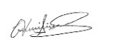 Date: 2022-09-26

I, Red Team MEMBER, **Li Yu # 2295012**, certify that I have contributed to this deliverable.

Date: 2022-09-26

I, Red Team MEMBER, **Patrick Larocque # 0879202**, certify that I have contributed to this deliverable.

Date: 2022-09-26

I, Red Team MEMBER, **Murat Osmonov # 219501**, certify that I have contributed to this deliverable.

Signature: Date: 2022-09-26

I, Red Team MEMBER, **Chi-Tao Li # 9730157**, certify that I have contributed to this deliverable.

Signature:  Date: 2022-09-26

|  |
| --- |
| Table of Contents |
| 1. **Statement of Prior Work …………………………………………………3** |
| 1. **Introduction …………………………………………………....….……... 4** |
| 1. **Executive Overview ………………………...……………….……...……. 4** |
| 1. **Summary Description of the Client.……………………….……...….…. 5** |
| 1. **Description of the Business Problem……………………………………..7** |
| 1. **Narrative Description of the Present Information System…………..….8** |
| 1. **Appendix 1 - Use Cases……………...……………….……….………...... 9** |
| 1. **Appendix 2 - Use Cases Templates….…...…………………………...... 11** |
| 1. **Appendix 3 - UML Diagrams...……………………………………….... 12** |
| 1. **Appendix 4 - Class Diagram……………………………………………..13** |
| 1. **Appendix 5 - State Chart Diagram……………………………………...14** 2. **Appendix 6 - Copies of Forms/Screenshots…………………………….15** 3. **References/Bibliography………………………………………………...16** |

**I. Statement of Prior Work**

The work herein is possible in part due cumulative learning assignments and projects undertaken in the past, as part of the team’s Software Development curriculum. As such, some of the ideas or technical skills used in this project originate partially from prior work. The table below lists past projects undertaken by members of the Red Team, which may contribute in part to elements found in the scope of this project.

|  |  |  |
| --- | --- | --- |
| Past Projects | Tools Used | Contributor(s) |
| Mock-ups for personal websites, Application Dev 1 | Adobe Photoshop, Cava, Figma | All membres |
| Simulation Program | Java and Java Swing | Chi-Tao Li |
| Car Rental System | MS SQL Server | All members |
| Inventory Management System | Apache Derby Database, Java, and Java Swing | Patrick Larocque |
| Issue Tacker | C#, Google API, .NET, Firebase | Patrick Larocque |
| Added Prior Works  used for this deliverable | Tools Used | Contributor(s) |
| Deliverable 1 Report | MS Word, Instagantt.com  (for Gantt Chart) | All members |
| Database course | Draw.io, Lucidchart | All members |
|  |  |  |
|  |  |  |
|  |  |  |
|  |  |  |

**II. Introduction**

This document is the third deliverable in a series of documents aimed at the assessment and diagnosis of business problems affecting a potential sponsor. The red team introduced Manoir Ramezay as that sponsor. The red team made a preliminary statement and diagrams about Manoir Ramezay’s present information system, based on the information available at the time and after a few phones’ interview, which deliverable third will attempt to build on.

**III. Executive Overview**

The following document outlines the red team's activities that include the extended version for the summary description of the client and the business problem because now we have a better understanding and more information's so that we can have a complete reasoning, always with respects to Manoir Ramezay.

The reader will also find a Narrative description of the present information system which followed from are previous tasks in which we analyzed the existing system in depth with the visualization of diagrams such as Use cases, UML, Class diagram and state chart diagram.

__________________________________________________________________

preliminary assessment of the business problems affecting Manoir Ramezay, as they are currently understood, and considering the research conducted thus far. To conclude, this report will outline a series of business specific questions, for which the team’s research activities did not yield satisfactory answers. The purpose of these questions is to gain a better understanding of the specific business processes in place at Manoir Ramezay.

Business domain research was conducted to better contextualize the business processes at Manoir Ramezay. Furthermore, the red team sought to better understand the trends and standard practices present in the hotel industry. Business environment research was conducted such that the red team may better understand how Manoir Ramezay has positioned itself in relation to the rest of the industry, its competitors, and the local market. In this section, the reader will find specific details and facts about the business, along with relevant information about the world in which the business operates. Following this section, the reader will find an updated client profile, describing the staff’s general computer literacy and confidence with respect to IT systems. This section assures us that any proposed business solutions are well suited to the staff that run Manoir Ramezay.

Afterwards, the reader will find an updated statement on the business problems affecting the business, considering the research conducted. Finally, the document will conclude with open questions and a questionnaire. These questions are aimed at uncovering the specific, day-to-day operations at Manoir Ramezay, such that the red team may refine its understanding of the problems the business is facing, along with what processes may or may not contributing be contributing factors. Along with business domain and environment research, which contextualizes business operations and informs the team’s open questions, the red team hopes that understanding the business processes, information systems, and staff at Manoir Ramezay will allow for a better diagnosis of the business problems and prototype solutions.

**IV. Summary Description of the Client**

Manoir Ramezay is a 3-star hotel located in Marieville \that owners bought it 4 years ago. This is the first time that owners manage the hotel business. They are of Chinese ethnicity, and they immigrated from China to Canada with their two children. During the four years they have been operating the hotel, their business is getting better.

The hotel has their own website. The website includes features typical for a hotel business, including a landing page which introduces the hotel along with images of its amenities,

pages that describe the services offered. Guests can make a reservation through their website, as well as the third-party platforms, namely Expedia, Booking.com and Airbnb.

Their primary method of bookkeeping is to keep a record of reservations inside of a physical ledger, which is updated each time a booking in made through any of the various booking channels. They may also print booking confirmations they receive via email, for the purpose of bookkeeping. Moreover, they have not modified the website, other than for the purposes of COVID updates, and much of the management practices have remained unchanged.

Regarding computer skills, both owners and their staff have working knowledge of Microsoft’s Office suite, along with a basic understanding of navigating the web, and using email services. Management has expressed a willingness to learn any new software tools, should it help them operate their business and solve their current business problems. Their business has grown since it was acquired, and the staff at Manoir Ramezay has voiced their desire to improve and modernize their management systems to solve the business problems they see themselves facing.

**V. Description of the Business Problem**

The hotel doesn’t have an efficient system in place to keep track of room availability across all their booking channels. When a room is booked through one of their platforms, front-desk staff must update a physical ledger or print out a confirmation from a third-party platform. Front desk staff must then manually change the room’s availability across all other platforms to avoid duplicate bookings and to reflect the actual availability. This is a very inefficient process, especially when the hotel is busy, during the summer months. The front-desk staff is often preoccupied with assisting on-site clients and fulfilling requests, so much so that they are unable to keep up with the current methods of data entry. The potential for double bookings, and overworked front-desk staff may lead to poor experience for the client, leading them to choose another establishment in the future. Moreover, if a repeat client returns to the hotel to book a room, the front-desk staff must reference the physical ledger or paperwork to find their personal information or preferences (if any were noted). This often leads to the client having to repeat much of the same information that was given during prior visits.

As it stands, the current business problem has to do with efficient booking management. The current process is inefficient, leading to inaccurate room tallies, overworked front-desk staff, an inability to answer client questions and the potential for poor client experience as a result. Writing down all guests’ information on paper is a slow and error prone process and appears to be a pain point with respects to the hotel’s day to day operations. Front-desk employees need to be able to quickly verify guest’s personal information for the check-in and check-out process to be as seamless as possible. Booking and client information is spread across many tools and platforms, each needing to be cross-referenced every time a booking is made. This creates a bottleneck for the business if it wishes to continue growing.

**VI. Narrative Description of the Present Information System**

Making a reservation at Manior Ramezay can be made in one of three ways. Online, by phone, or in person. A reservation made online can be made through several different booking platforms. Namely, directly through Manoir Ramezay’s [website](http://www.manoirramezay.com/index_e.html), or through one of several third-party booking platforms (Booking.com, Expedia, Hotels.com, Priceline.com, etc...). Booking online sees the prospective guest access one of the booking platforms. The guest then browses a selection of rooms, until they have made a choice. The guest then verifies that the room that satisfies their needs is available on the dates they wish to visit. The booking platform returns the availabilities to the user, at which point the user may choose to proceed with their reservation. The booking platform will request the guest’s personal information, which includes the name of the primary guest, the names and number of additional guests, the primary guest’s address, phone number, email address and date of birth. Once the guest has provided the necessary personal information, they will be presented with a choice of payment options. The guests pay provide a credit card for immediate payment or for a hold/deposit to be placed on their credit card. Alternatively, they can pay in cash, or debit during their check-in, however, a credit card number is still necessary to secure their reservation. Once the guest has provided their payment information, their reservation is confirmed. They will receive a confirmation email, and the booking platform will also send a notification email to Manoir Ramezay with the guest’s booking information. Staff at Manoir Ramezay must then update other booking platforms, along with their physical ledger, to reflect the change in availabilities across all platforms.

Guest may also call in to book a reservation. In this instance, the clerk or receptionist will handle the guests’ requests by fielding relevant questions pertaining to the rooms and current availabilities. Choose the potential guest wish to proceed, the receptionist will then gather the guest’s personal and payment information and send the guest a confirmation email. The receptionist must then ensure to update the hotel’s availabilities across all channels once again. A walk-in reservation functions in much the same manner. However, the guest is provided a physical form to be filled out, which serves to record all the relevant personal and payment information. Finally, the receptionist will enter the reservation details and, if they stay is immediate, the client will provide payment and check into their rooms, else, if the stay is for a future date, they will be sent a confirmation email. The reservation form will be stored in a physical ledger for future reference. Once again, the receptionist must update availabilities across all booking channels.

**VII. Appendix 1 - Use Cases**

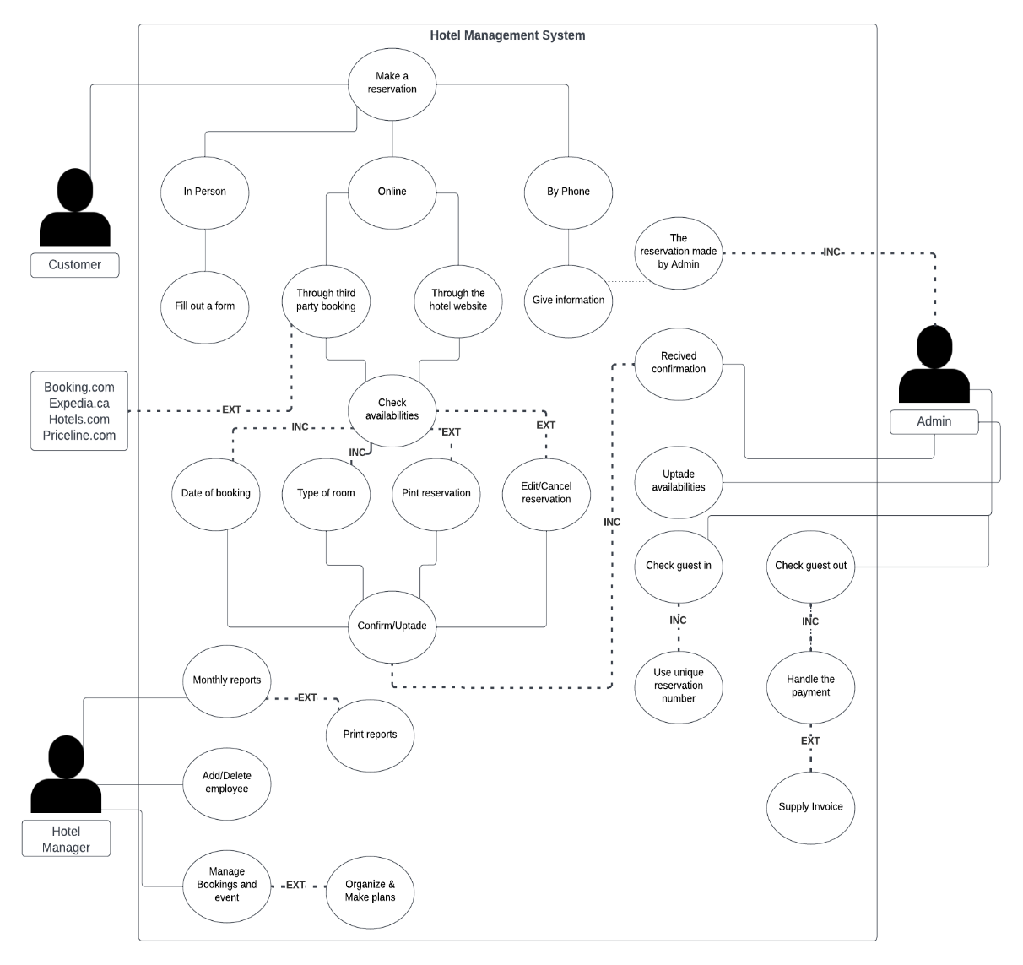

**VIII. Appendix 2 - Use Cases Templates**

Make an online booking

|  |  |  |  |  |
| --- | --- | --- | --- | --- |
| **Use Case ID:** | #1 Booking online | | | |
| **Use Case Name:** | Make an online booking | | | |
| **Created By:** | Murat | | **Last Updated By:** |  |
| **Date Created:** | 2022-10-05 | | **Last Revision Date:** |  |
| **Actors:** | | Client | | |
| **Description:** | | Book a room at hotel | | |
| **Trigger:** | | When client access online booking | | |
| **Preconditions:** | | Client is logged and has access to hotels site | | |
| **Postconditions:** | | online booking works around the clock, visitors can automatically book a hotel room at any time | | |
| **Normal Flow:** | | 1 Client enters a gateway for hotel  2 Client chooses, check in and check out dates, and room type  3 The system provide availability and price  4 Client accepts and asks for a room.  5 Client provide name and required information  7 The system makes a booking and assigns a booking number  8 The system shows reservation number to client  9 The system creates and sends a confirmation to client by email  10 hotel staff receive information about a new booking, which allows them to immediately prepare a room, distribute tasks and provide quality services to the client | | |
| **Alternative Flows:** | | At 2a) Required room not available  At 2b) The system offers alternative rooms | | |
| **Exceptions:** | | At 3a) Client declines offer  At 3b) Exit | | |
| **Includes:** | | None | | |
| **Frequency of Use:** | | Every time when a client booking. 2-6 time daily. | | |
| **Special Requirements:** | | None | | |
| **Assumptions:** | | None | | |
| **Notes and Issues:** | | None | | |

Online payment

|  |  |  |  |  |
| --- | --- | --- | --- | --- |
| **Use Case ID:** | #2 online payment | | | |
| **Use Case Name:** | Payment | | | |
| **Created By:** | Murat | | **Last Updated By:** |  |
| **Date Created:** | 2022-10-05 | | **Last Revision Date:** |  |
| **Actors:** | | Client | | |
| **Description:** | | To pay for the booking room | | |
| **Trigger:** | | When a client decides to pay for the booking room | | |
| **Preconditions:** | | Client must have username, password and credit card.  Client must has to provide correct information.  The system has information of booking room by client | | |
| **Postconditions:** | | System must be working  Client receives booking information | | |
| **Normal Flow:** | | 1. Client log on system.  2. Client enter their user ID and password.  3. The system requests customer payment information.  4. Client fills the information about payment.  a. Client enter amount of money  b. Client enter credit card number, security cod and expiration date  c. Client confirm operation  5. Client information and payment are verified  6. Client information is documented in the system  7. The system generates and sends an booking information to the client by e-mail | | |
| **Alternative Flows:** | | 2a) If user ID and password are incorrect, the system will prompt to client to retry to log on.  4a). Client payment information is invalid.  4b). The system asks the client to re-enter their payment information; it is possible that the client made a mistake. | | |
| **Exceptions:** | | 4c). If the payment information is still invalid  4d). The system rejects the request | | |
| **Includes:** | | None | | |
| **Frequency of Use:** | | Every time when a client booking room online. 2-7 time daily. | | |
| **Special Requirements:** | | None | | |
| **Assumptions:** | | None | | |
| **Notes and Issues:** | | None | | |

1. **Appendix 3 - UML Diagrams**
2. **Appendix 4 - Class Diagram**
3. **Appendix 5 - State Chart Diagram**
4. **Appendix 6 - Copies of Forms/Screenshots**

**BOOKING.COM**

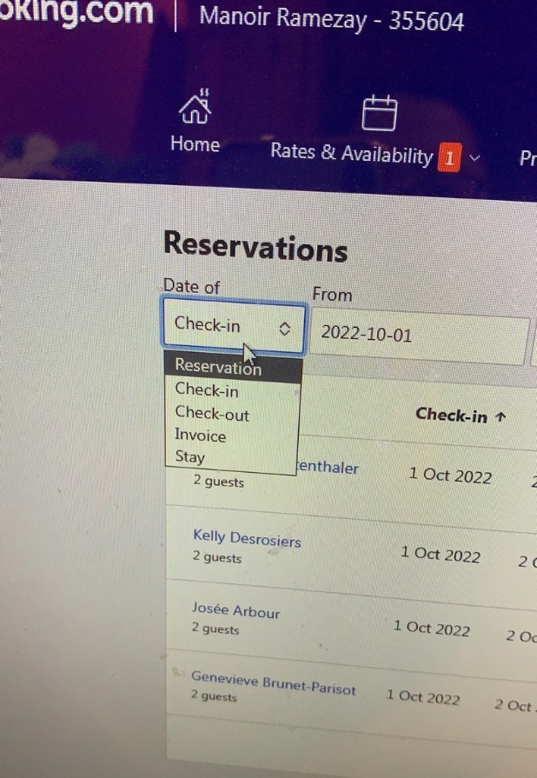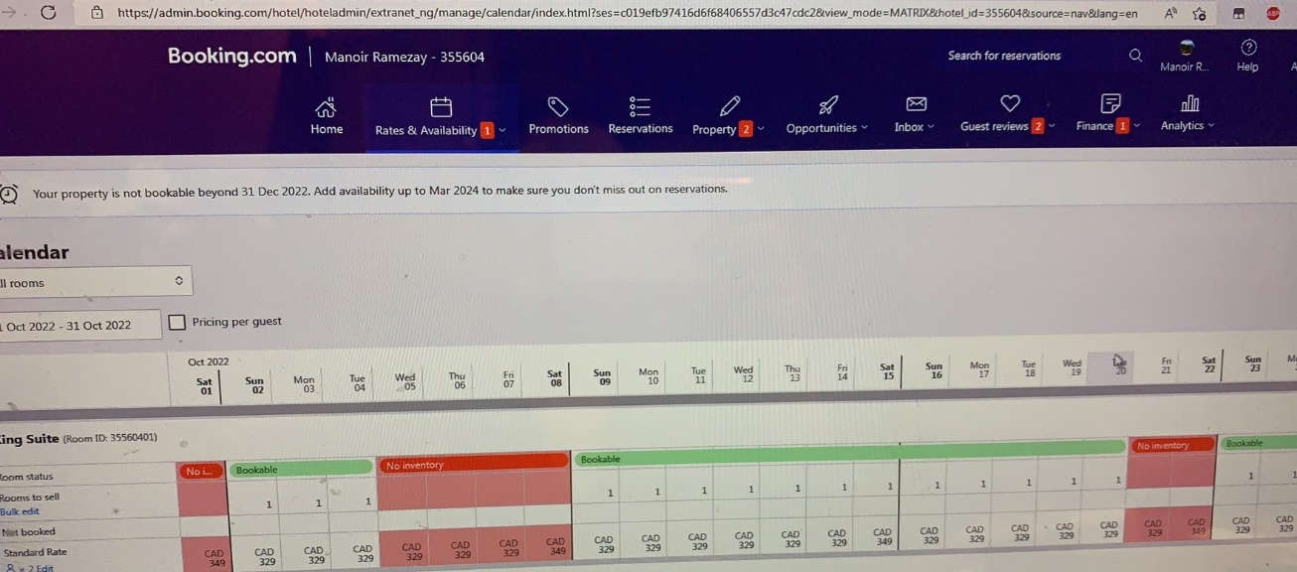

**EXPEDIA.COM**

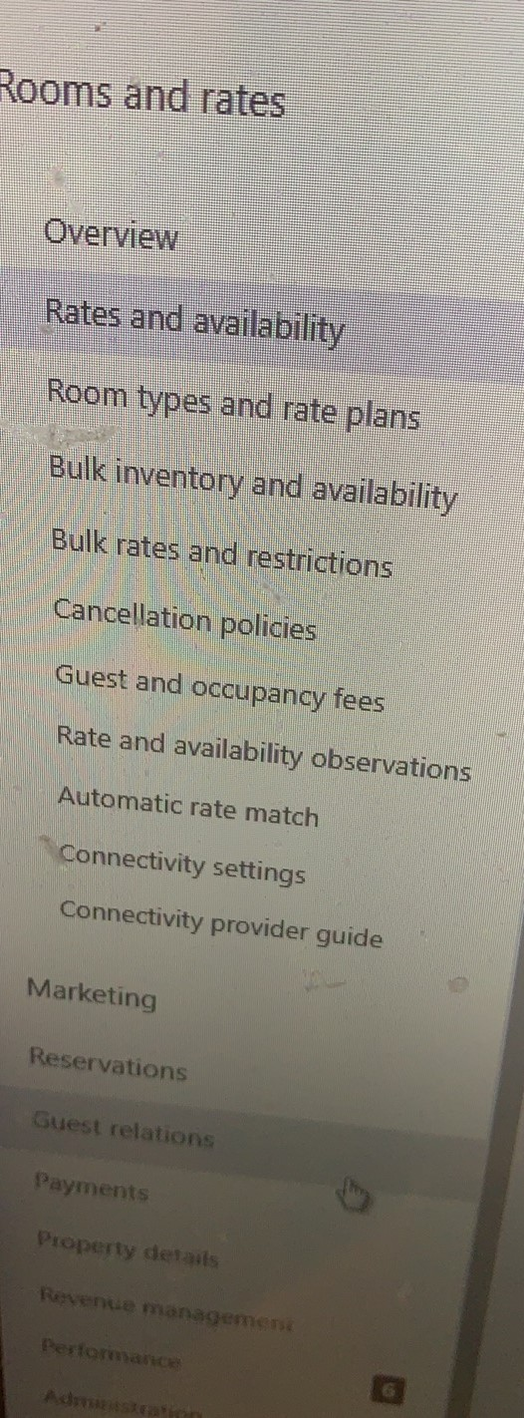

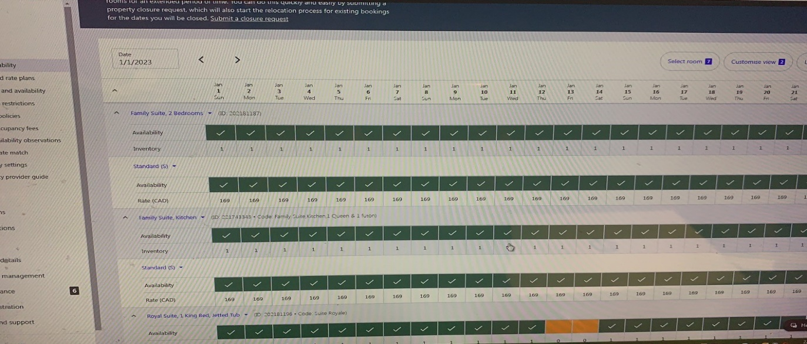

**HOTEL WEBSITE**

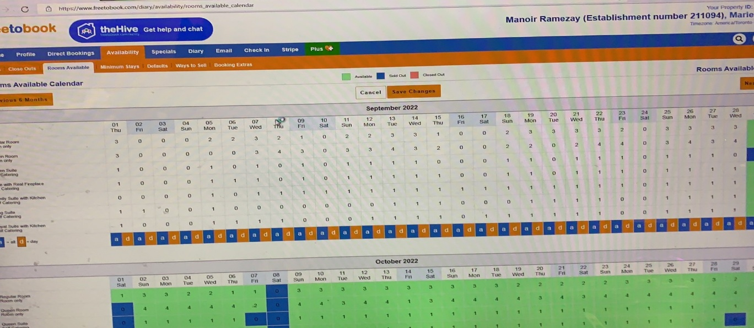

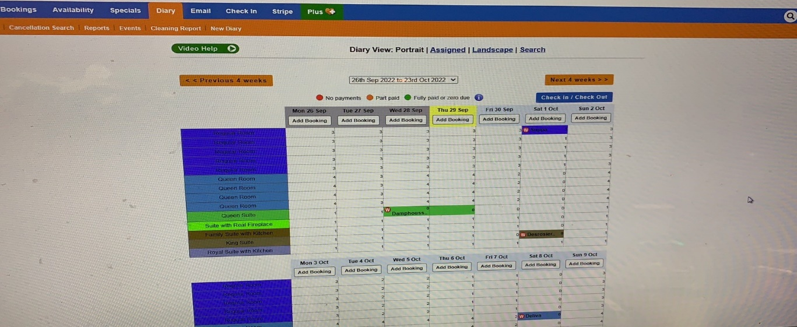

**IN PERSON**

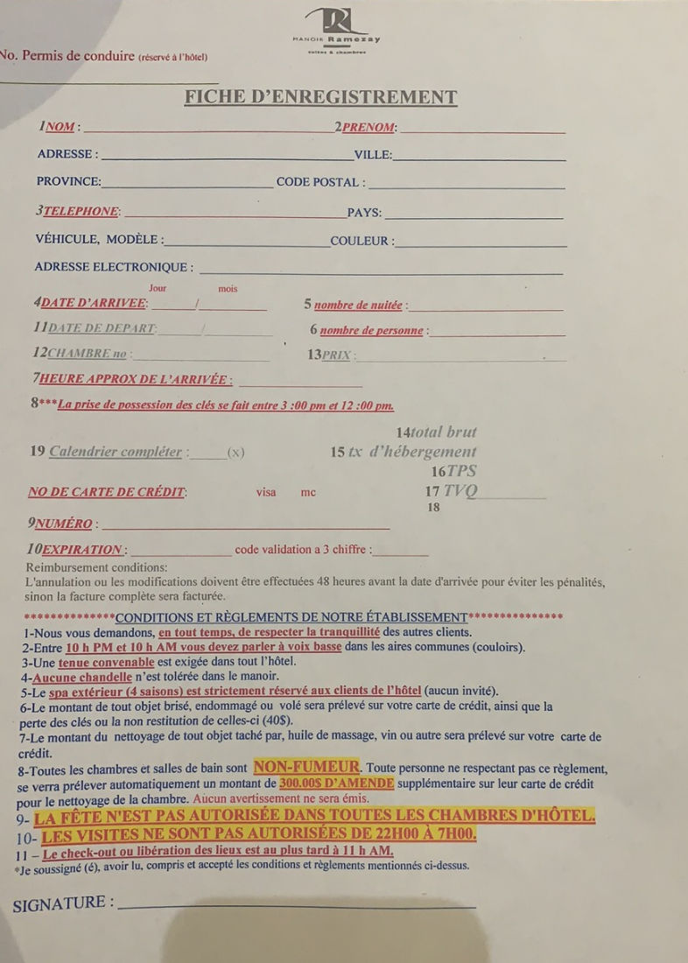

**XIII. References/Bibliography**

Revfine.com. (2022, June 20). *Hotel Industry: Everything You Need To Know About Hotels!* Revfine.com. Retrieved September 26, 2022, from <https://www.revfine.com/hotel-industry/>

O’Fallon, M. J., & Rutherford, D. G. (2010, January 12). *Hotel Management and Operations*. John Wiley & Sons, Inc.

Parker, K. (2009, February 1). *How to buy & run a small hotel: 5th edition* (5 Rev Upd). How To Books.

*What is a room type? (+20 types of hotel rooms)*. Hotel Tech Report. (2022, January 26). Retrieved September 26, 2022, from <https://hoteltechreport.com/news/room-type>